RESOURCE ALLOCATION MODULE VALIDATION AND EVIDENCE DOCUMENTATION
1. Objective
The Resource Allocation Module was developed to convert hotspot severity information into actionable municipal deployment recommendations. The module utilizes DBSCAN hotspot rankings and Smart Waste Severity Index (SWSI) scores to determine the number of workers and vehicles required for waste collection operations.
The objective is to support data-driven resource planning by prioritizing highly affected areas and optimizing operational efficiency.

2. Resource Allocation Framework
The Resource Allocation Module receives hotspot information generated by the DBSCAN clustering stage.
Input Parameters
Parameter | Source
Cluster ID | DBSCAN Output
Average SWSI | SWSI Framework
Hotspot Priority | DBSCAN Ranking
Output Parameters
Parameter | Description
Workers | Number of sanitation workers assigned
Vehicles | Number of waste collection vehicles assigned

3. Integration within Proposed Framework
The allocation process is integrated into the overall system workflow.

Waste Image
↓
YOLOv8 Detection
↓
Waste Count Extraction
↓
AHP-Based Weighting
↓
SWSI Calculation
↓
DBSCAN Hotspot Detection
↓
Hotspot Prioritization
↓
Resource Allocation
↓
Dashboard Visualization
↓
Municipal Decision Support

This establishes complete traceability from waste detection to resource deployment.

4. Resource Allocation Logic
The allocation module follows a priority-based deployment strategy.
Allocation Rules
Priority Level | Workers | Vehicles
Priority 1 | 6 | 3
Priority 2 | 4 | 2
Priority 3 | 2 | 1
Decision Principle
Higher-priority hotspots receive:
- More sanitation personnel
- More waste collection vehicles
- Faster intervention
Lower-priority hotspots receive:
- Routine monitoring
- Reduced resource deployment
- Scheduled cleanup operations

5. Resource Assignment Algorithm
The resource assignment algorithm operates as follows:
Step 1
Receive hotspot clusters from DBSCAN.
Step 2
Calculate average SWSI for each cluster.
Step 3
Rank clusters according to average SWSI.
Step 4
Assign priority levels.
Step 5
Allocate workers and vehicles according to predefined deployment rules.
Step 6
Generate recommendations for dashboard visualization.

6. Cluster Severity Analysis
The hotspot clusters generated by DBSCAN produced the following average severity values.
Cluster | Average SWSI | Priority
0 | 79.11 | 1
1 | 45.31 | 2
2 | 20.70 | 3
Evidence Source
DBSCAN Notebook Output
Validation Type
Actual Generated Results
Reproducible
Yes

7. Resource Allocation Results
The allocation module generated the following deployment recommendations.
Cluster | SWSI | Priority | Workers | Vehicles
0 | 79.11 | 1 | 6 | 3
1 | 45.31 | 2 | 4 | 2
2 | 20.70 | 3 | 2 | 1
Evidence Source
Allocation Notebook Output
Validation Type
Actual Resource Allocation Result
Reproducible
Yes

8. Deployment Scenario Analysis
Scenario 1: High-Severity Hotspot
Cluster 0
Parameter | Value
Average SWSI | 79.11
Priority | 1
Workers Assigned | 6
Vehicles Assigned | 3
Interpretation
This hotspot exhibits the highest waste severity and therefore receives maximum operational resources.
Recommended Action:
- Immediate cleanup operation
- Intensive waste collection
- Continuous monitoring

Scenario 2: Medium-Severity Hotspot
Cluster 1
Parameter | Value
Average SWSI | 45.31
Priority | 2
Workers Assigned | 4
Vehicles Assigned | 2
Interpretation
Moderate waste accumulation requires scheduled intervention and periodic monitoring.
Recommended Action:
- Scheduled cleanup
- Moderate workforce deployment
- Regular inspections

Scenario 3: Low-Severity Hotspot
Cluster 2
Parameter | Value
Average SWSI | 20.70
Priority | 3
Workers Assigned | 2
Vehicles Assigned | 1
Interpretation
Low waste severity indicates routine maintenance requirements.
Recommended Action:
- Periodic monitoring
- Routine collection schedule
- Minimal resource deployment

9. Resource Allocation Visualization
Two validation plots were generated.
Figure X
Worker Allocation by Hotspot Cluster
Evidence File:
worker_allocation.png
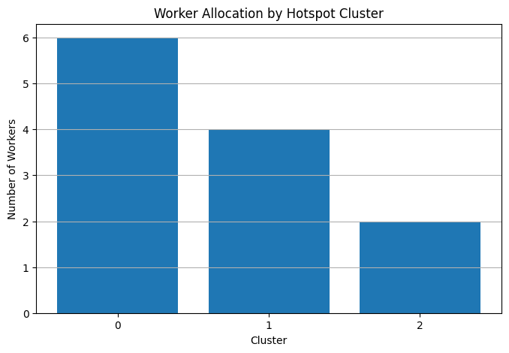
Validation:
Visual Verification of Workforce Distribution
Figure Y
Vehicle Allocation by Hotspot Cluster
Evidence File:
vehicle_allocation.png
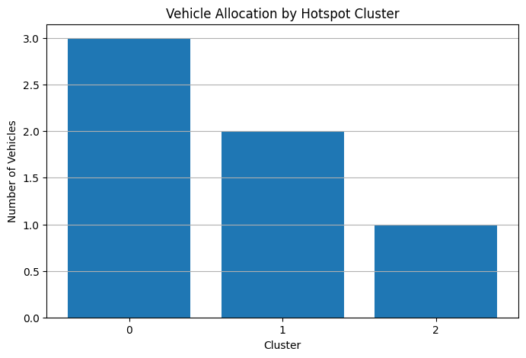
Validation:
Visual Verification of Vehicle Distribution

10. Resource Optimization Analysis
The allocation strategy ensures that municipal resources are deployed proportionally to waste severity.
Benefits
- Efficient workforce utilization
- Reduced operational costs
- Faster response to critical hotspots
- Improved waste collection efficiency
- Data-driven decision support
The framework prevents over-allocation to low-priority regions while ensuring adequate coverage of critical zones.

11. End-to-End Validation
The complete decision-support pipeline was successfully validated.
YOLOv8 Detection
↓
Waste Count
↓
AHP Weighting
↓
SWSI Generation
↓
DBSCAN Hotspot Detection
↓
Priority Ranking
↓
Resource Allocation
↓
Dashboard Recommendation
↓
Municipal Action

Evidence Sources
- YOLOv8 Results
- AHP Notebook
- SWSI Notebook
- DBSCAN Notebook
- Resource Allocation Notebook

12. Result Traceability Matrix
Result ID | Output | Evidence | Validation Type | Reproducible
RA1 | Cluster Severity Ranking | DBSCAN Notebook | Statistical Validation | Yes
RA2 | Priority Assignment | Allocation Notebook | Decision Logic Validation | Yes
RA3 | Worker Allocation | Allocation Notebook | Resource Mapping Validation | Yes
RA4 | Vehicle Allocation | Allocation Notebook | Resource Mapping Validation | Yes
RA5 | Deployment Recommendations | Allocation Output Table | Operational Validation | Yes
RA6 | Worker Allocation Plot | worker_allocation.png | Visual Validation | Yes
RA7 | Vehicle Allocation Plot | vehicle_allocation.png | Visual Validation | Yes
RA8 | Dashboard Recommendations | Dashboard Module | Integration Validation | Yes
RA9 | End-to-End Decision Support | Complete Framework | System Validation | Yes

13. Evidence Checklist
Evidence Item | Status
Resource Allocation Code | ✓
Priority Mapping Logic | ✓
Cluster Ranking Results | ✓
Worker Allocation Results | ✓
Vehicle Allocation Results | ✓
Deployment Scenarios | ✓
Resource Allocation Visualization | ✓
Traceability Matrix | ✓
End-to-End Integration
Dashboard Integration

14. Conclusion
The Resource Allocation Module successfully transformed hotspot severity information into actionable deployment recommendations. Using DBSCAN-generated hotspot rankings and SWSI-based severity assessment, the framework allocated workers and vehicles according to operational priority. The resulting recommendations support efficient municipal resource utilization and provide a practical decision-support mechanism for smart-city waste management.

